NAMA : ZAKY APRILIAN

NIM : 102022300212

KELAS : SI4702

ASISTEN CODE : HAQI

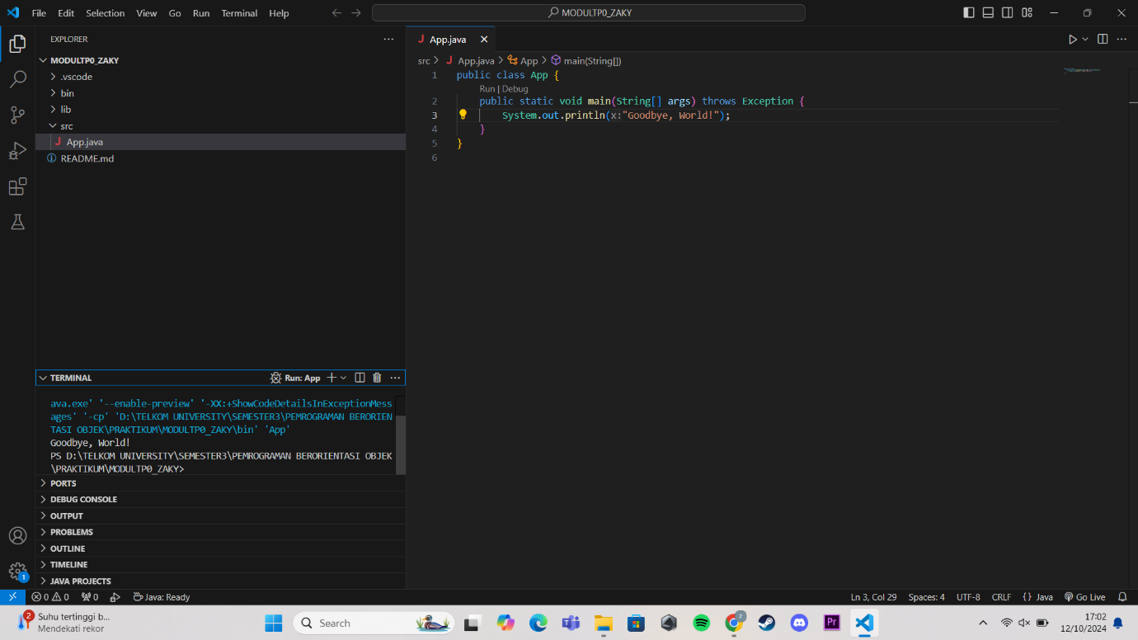

Link GitHub: <https://github.com/Zakyap17/OOP-HAQI-ZAKY-102022300212>